MID-EVALUATION REPORT ON

DYNAMIC ADAPTATION OF DIGITAL WORKSPACE

OVERVIEW OF PROPOSED PROJECT

My submitted proposal for BYOP’24 contained the idea of designing and implementing an adaptive system using machine learning to mutate the digital workspace. A digital workspace includes all microcomputer devices such as desktops, laptops, tablets and smartphones. My idea of creating an adaptive workspace was bringing in the element of dynamic change (without explicit user intervention) in display settings, volume settings, battery plans and overall optimisation of computing resources. The latter was the initial target feature: killing of background tasks to create a more efficient ‘workspace’ for a user curated according to their behaviour and preferences.

INITIAL INPUTS RECEIVED BY MENTOR AND SUBSEQUENT CHANGES

The target features and coding required for desktops/laptops compared to smartphones are quite distinct. I was suggested by my mentor to narrow my focus for the scope of this project to one type of microcomputer and I picked Windows desktops/laptops. I proposed to have a regression-based model: letting a numerical value reflect the degree of appropriateness of each curated focus mode. During the learning phase, classification seemed to be the better option in automating the mode change according to user task with a choice among decision trees, random forest and XGboost models.

SEARCH FOR DATASET DURING THE LEARNING PHASE

Originally intending to feed my model user digital settings and preferences throughout the day as a dataset and having done minimal research about the availability of such datasets prior to my proposal submission, I found no such dataset. Additionally trying to find datasets based on individual metrics like screen brightness, desktop usage, app usage, volume activity or as later suggested by my mentor, datasets on orientation of various desktop peripherals also did not yield any results.

The dataset now being used was found on Kaggle under the title of “Eye Movement Data Set for Desktop Activities”. So, instead of going for a track of app usage statistics or user PC preferences throughout a day and building further off of that, I will now be using this data set to make a model that discerns the activity being performed by the user according to the eye movement.

CHANGE IN GOAL ALIGNMENT

Changed project goal still targets the original optimisation goal as on the basis of the activity prediction made by my model, I will define classes targeting refresh rate, battery plan and brightness setting of the underlying system.

Brightness contributes to display as an integral part and is one of the most power-hungry resources. Better management of optimal brightness will contribute to overall battery health.

Change of refresh rate helps to decrease power consumption by the display subsystem and improves graphics processing efficiency when lowered during certain tasks.

As supported by my laptop and most Windows-based systems, there are 3 power plans that can be chosen in addition to any extra custom battery plans: best power efficiency, balanced and best performance. Selection of appropriate battery plan allows to fine tune many system settings like processor power management and system cooling policies to match specific needs and perform more power efficient functions.

ORIGINAL DATASET

My dataset was derived from the dataset provided on Kaggle as supporting evidence for the paper published with the citation mentioned below:

*Srivastava, N., Newn, J., & Velloso, E. (2018). Combining Low and Mid-Level Gaze Features for Desktop Activity Recognition. Proceedings of the ACM on Interactive, Mobile, Wearable and Ubiquitous Technologies, 2(4), 189*

Original dataset contains data recorded by the setup of a desktop mounted Tobii X2-30 eye tracker and Tobii Pro Studio software. I have not looked into the alternate non-invasive setups that I can use for the eye movement tracking since that is not what my ML project entails but relies on.

Dataset is based on human activity recognition and banks on the correlation between eye-movement patterns and the underlying activities being performed. It holds datapoints of 8 activities being performed by 24 participants, classified using supervised ML algorithms by the curators.

3 subgroups of the test subjects were formed and significantly varying material were presented on screen to ensure variance yet establish a general trend and pattern of eye movement associated. The research paper reviewing the literature goes to discuss the difference in low-level, mid-level and high-level gaze features but it bears significance only for the purpose of research in that domain.

MODIFICATION OF DATASET AND EDA

* REDUCTION OF ACTIVITIES

Out of the 8 activities, seeing the visualised pattern of the dataset, for my model to be able to make clear distinctions, I chose the following 6 activities dropping Search analogous to Browse and Interpret analogous to Debug.

READ: focused reading so as to avoid the norm of skimming

WATCH: a 5-6-minute-long video with visual stimulus in form of a number of main characters adding variation

BROWSE: free browsing and interaction with news websites and blogs

PLAY: three free-to-play online games

*I have chosen my dataset to incorporate the participants asked to play games with the main character affixed to the center of the screen, seeing the growing interest in FPS games in recent times.

DEBUG: function implementation with multiple bugs to identify and fix, allowing no resource consultation outside the IDE

WRITE: code writing to implement a given set of functions and problems

The raw gaze data provided was a categorical time-series data with horizontal (x) and vertical (y) gaze coordinates. The dataset furnished in the Kaggle post had adjustments to control fixation parameters like average windows size and peak threshold.

* REDUCTION OF FEATURES

Since my model will be trained on recognising activity (target variable) on the basis of a given set of datapoints under columns/features ‘x’ and ‘y’, the features of ‘set’ and ‘timestamp’ were dropped during my data cleaning and reduction. Presented below is a snippet of the raw dataset as downloaded from Kaggle.

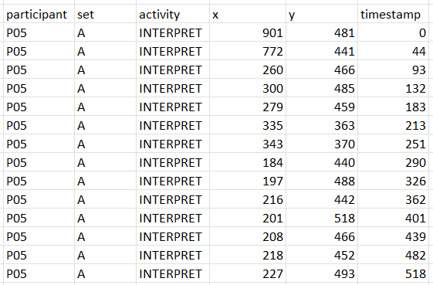

Out of the 24 participants, I chose 10 participants per activity to use the dataset of according to the varied stimulus they were subjected to. Raw datasets even after choosing the participants and removing outliers had csv plots that looked similar and would hamper the prediction being made by any underlying model because of the similar nature of the plots.

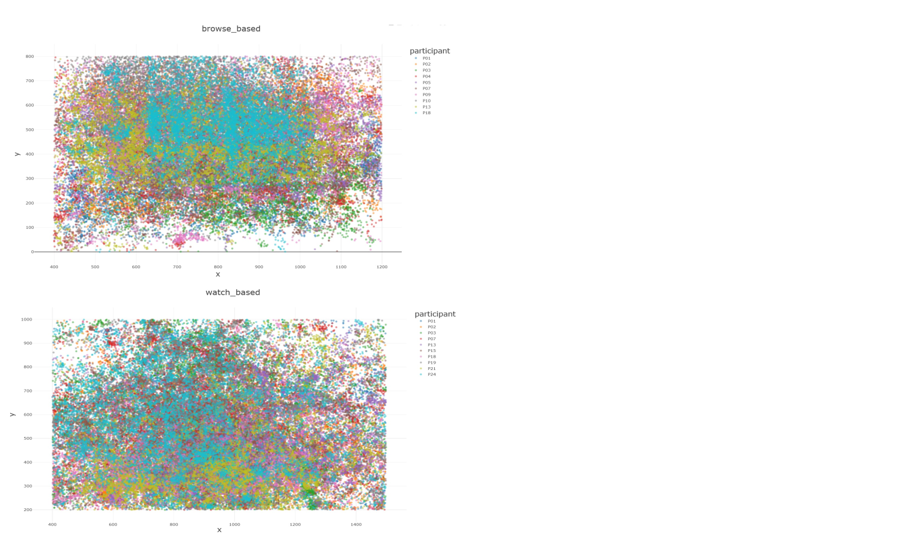

plotted on [www.csvplot.com](http://www.csvplot.com) using normalized datasets

Therefore, duplicate datapoints were removed and manual cleaning of the edges of each of the 6 datasets was done using MS Excel. The plots now look more distinct.

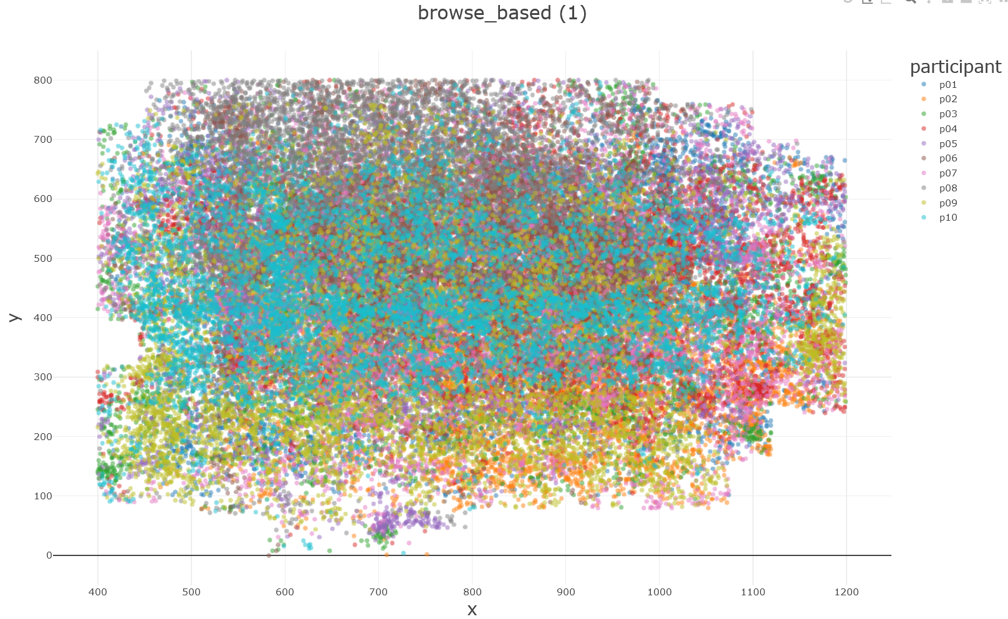 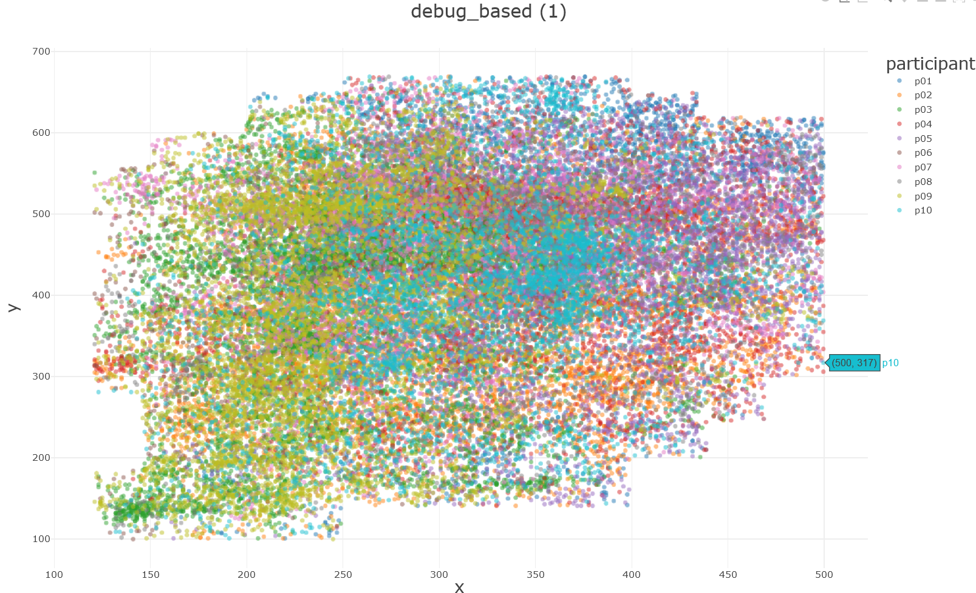

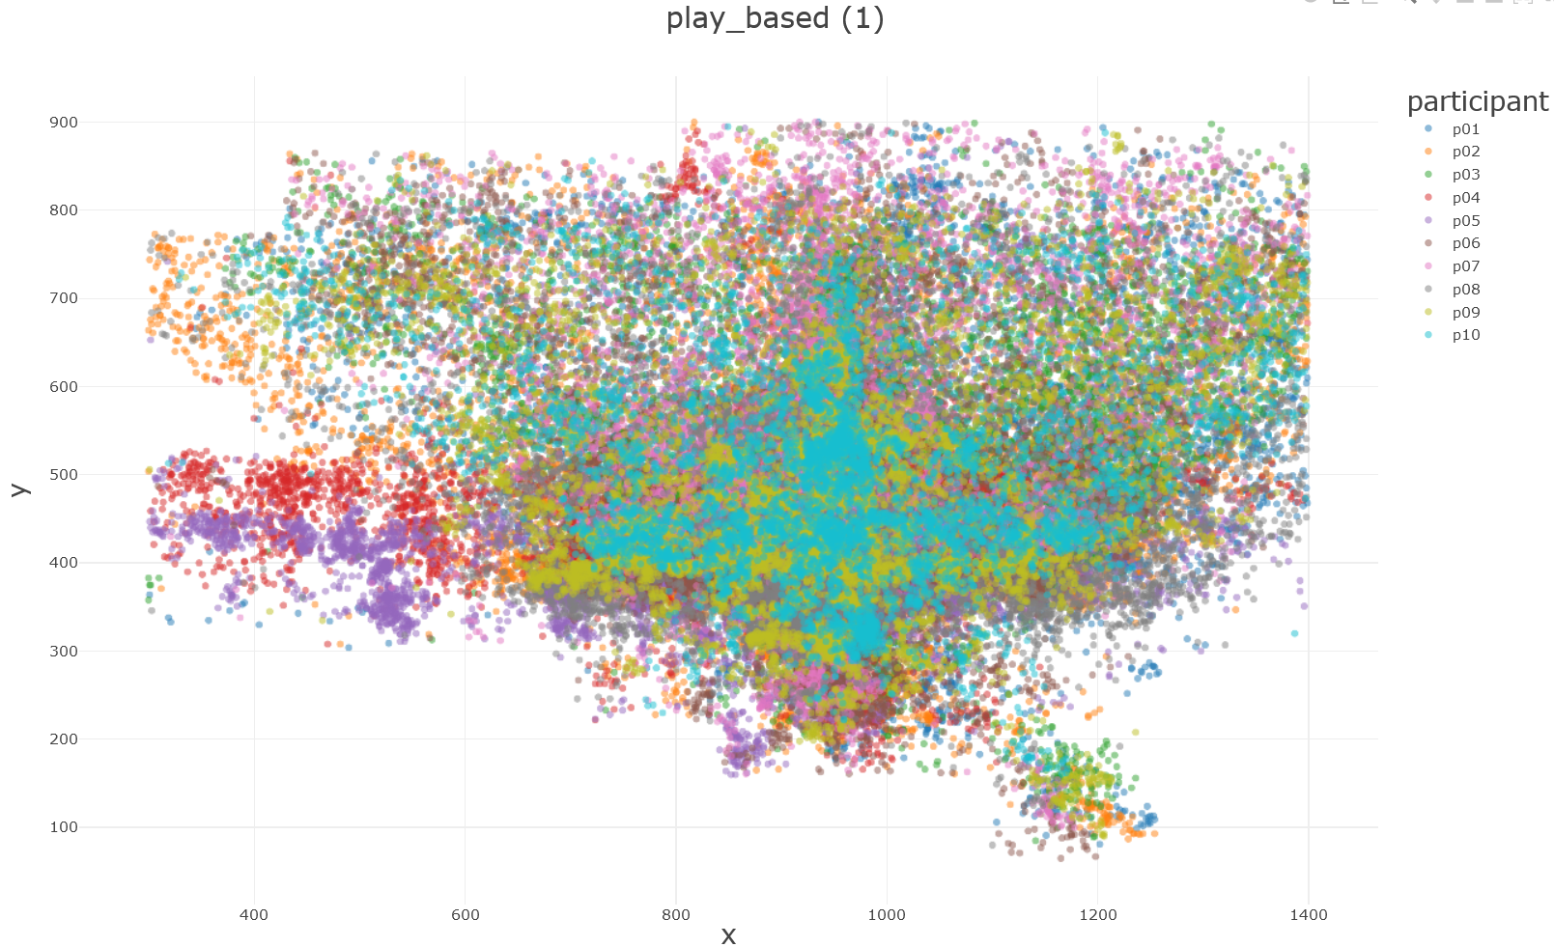 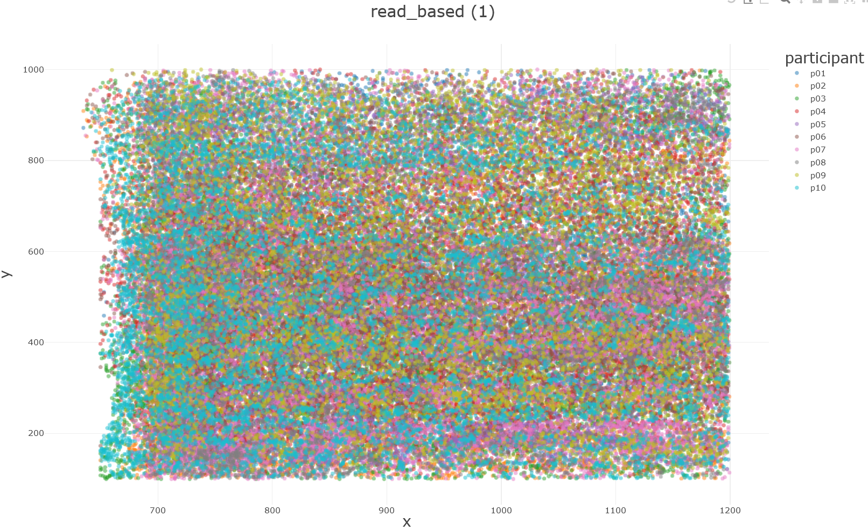

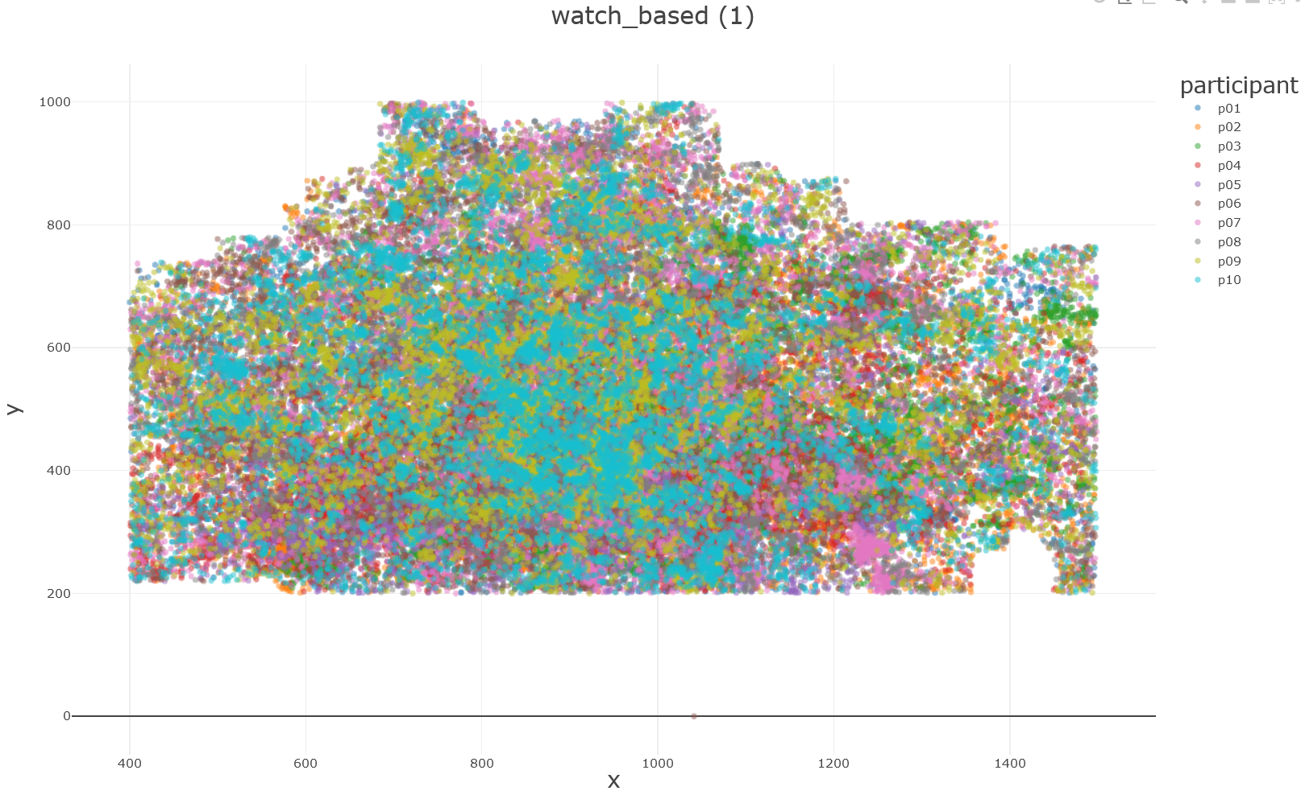 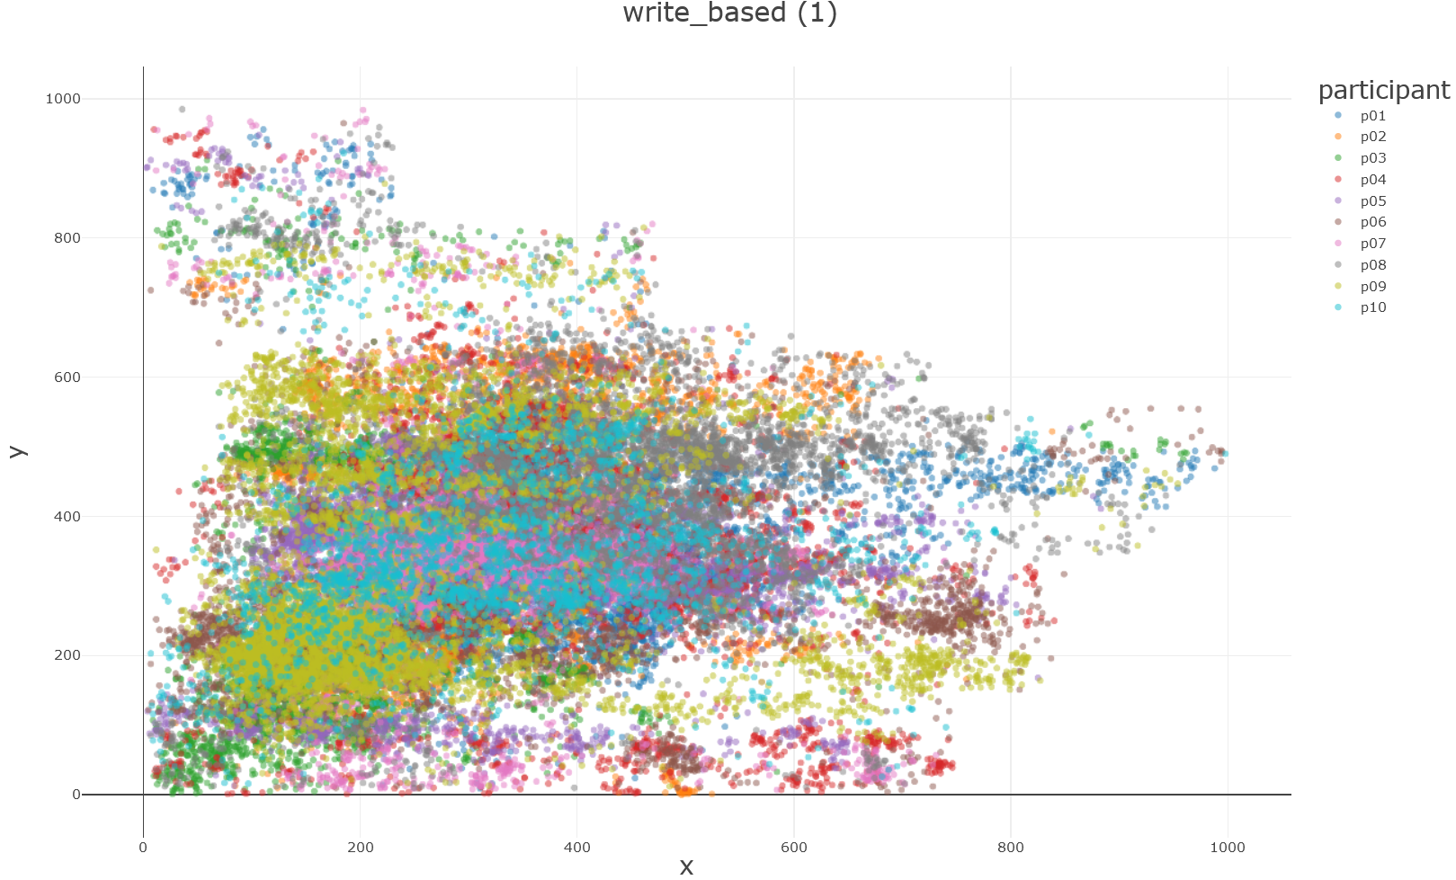

DETAILS OF DATASET SPLIT

Since a simple set of datatpoints being used for validation and testing will require the use of a specific subset of values that were not introduced to the model during training, manual splitting of train, validation and test dataset was done.

* TRAINING DATASET

The training dataset includes raw gaze coordinates of 6 participants performing the above mentioned 6 activities. The class distribution i.e., number of samples and their proportion in the training dataset is given below:

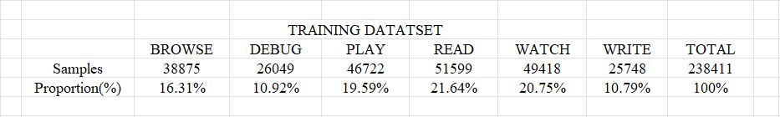

* VALIDATION AND TEST DATASET

During training, to validate my model’s working, I will be adding a specific subset picked from the Merged Validation Dataset. The Merged Validation Dataset will include datapoints corresponding to P07’s and P08’s (P implying participant) 6 activities that they have performed.

Being a supervised learning alogrithm governed task, the model will iteratively predict and adjust to reach the correct answer in accordance with the label of the activity given in the subset taken from the validation set.

The test dataset will similarly contain P09’s and P10’s datapoints for the six activites, subset of which can be chosen to test the model finally.

LINK TO ALL THREE DATASETS UPLOADED ONTO MY GOOGLE DRIVE:

<https://drive.google.com/drive/folders/16eG2Rrz1CH-vxy7SaSZVQcW_hj8tPKBE?usp=sharing>

LINK TO GOOGLE COLAB NOTEBOOK CONTAINING THE DATA LOADING CODE TO ACCESS AND REVIEW DATASET:

<https://colab.research.google.com/drive/1mxV62Z0NbBhb7XWsclN76LWBRWNULYVy?usp=sharing>

PLAN AND IMPLEMENTATION

* CURRENT PROGRESS



Since I have a large categorical dataset to work with, an ensemble learning model would help optimise better predictive performance and decrease the variance of the single estimate.

Ensemble Bagging over Boosting: XGBoost utilises way more underlying computer resources. Since my code is going to have to run on a local machine so as to access the Windows API, I will be choosing Random Forest Classifier as the ML algorithm.

* RANDOM FOREST CLASSIFIER ALGORITHM

To make a context-aware interactive system, choosing Random Forest Classifier leverages the collection of multiple decision trees trained on random subsets derived from the provided training data. Since random forest considers a random subset of features as well during the splits, in case of my dataset, it also considers 'participant' as a feature to have weightage in the predicitons. This is solved by my dataset having all six activities have equal percentage of datapoint contribution per participant. While the model is capable of digesting categorical data, it performs better when fed numerical data. Thus during dataset loading and preprocessing, I changed the ‘participants’ label from a string data type to a numeric data type by encoding.

The architecture of a Random Forest Classifier model based on my understanding is:

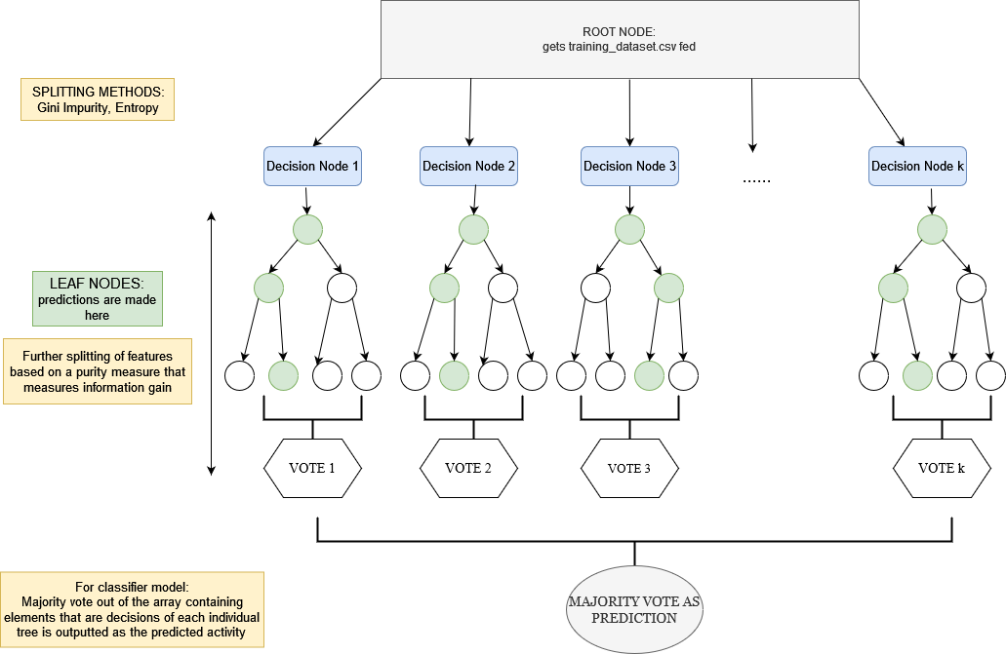

Widely acclaimed to be easier to tune and avoid overfitting of data as an inherent property of the model, it will base its final prediction on the result of many decision trees. The ML model works on the basis of bootstrap aggregation.

For understanding the model by hands on experience, I fed the model two different datasets stemming from my mentioned training dataset itself.

LINK TO EXAMPLE DATASET 1 AND 2:

<https://drive.google.com/drive/folders/11o8wCaT7gYdx6-5o5wHUiXFR2mhv84cl?usp=sharing>

LINK TO GOOGLE COLAB NOTEBOOKS FOR EXAMPLE 1 AND 2:

<https://colab.research.google.com/drive/1eHMVtvho4peY1Z3N0rd4fdGbieU4hWbO?usp=sharing>

<https://colab.research.google.com/drive/19YcCWkfsDuoEOEwxDMrfJTbNEAw4lBDL?usp=sharing>

The class distribution of both the example datasets is provided below:

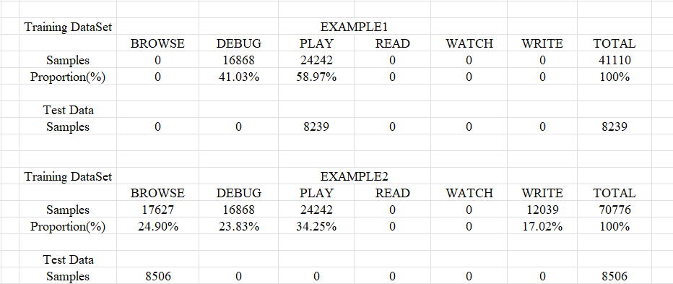

Training of models to fit the dataset involves feeding of loss to the model for it to learn and rectify its probable mistakes. Hyperparameter fine tuning also ensures that an ML model has enhanced predictive power in its next iteration.

Official documentation reports RandomForest Classifier to have 18 different hyperparameters that can be varied for tuning. But Random Forest is one such ML algorithm that is able to produce good results even with the default hyperparameter settings. So on running through one iteration of the model on example 1, I got the following reports:

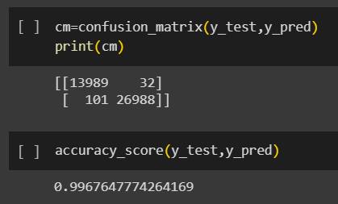 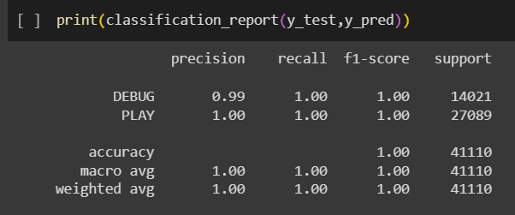

Example dataset1 is an extremely small subset with datapoints that could probably enable the model to report near-perfect accuracy. So, I experimented with example dataset 2.

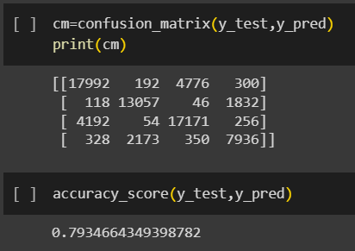 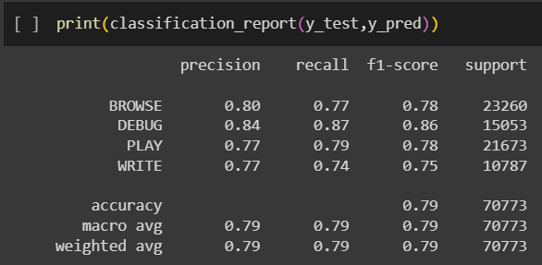

Increasing the dataset fed during training in terms of number of datapoints and possible target activities caused the accuracy and other precision metrics to drop off significantly. Figuring out the optimum hyperparameter settings for my model will be my task for after the mid-evaluation. I will also be exploring the difference in contribution of the features as the dataset width is increased.

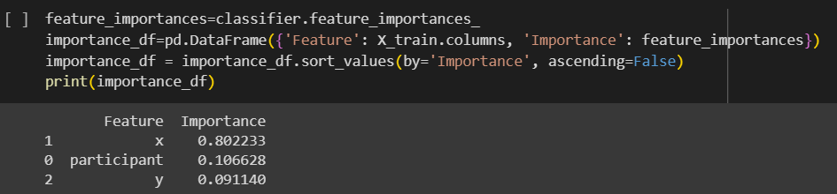

EXAMPLE 1

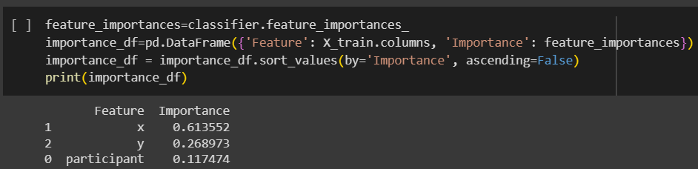

EXAMPLE 2

Since there is a significant difference in number of datapoints belonging to each class, I will be using the entropy criterion instead of the gini criterion for all my iterations.

I have summed up the project pipeline architecture in the chart given below:

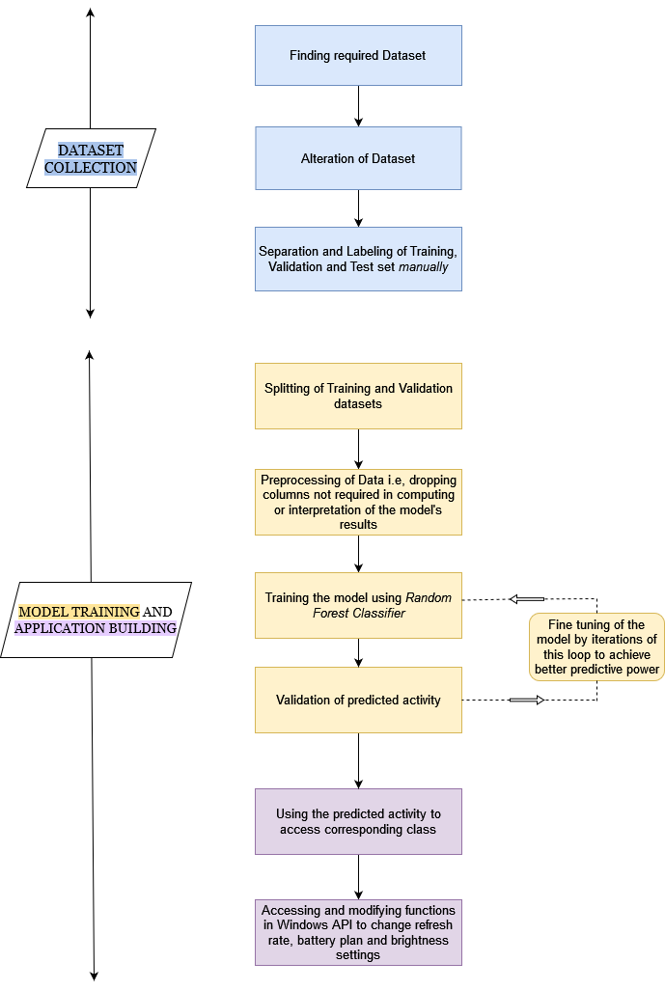

BUILDING OF THE CODE FOR FURTHER APPLICATION OF THE RESULT GATHERED FROM THE CHOSEN ML MODEL

Using the following snippet of code that I used in my colab notebook to print the majority vote, I can tap the predicted activity and call the corresponding class I will have created to alter refresh rate, battery plans and brightness settings.

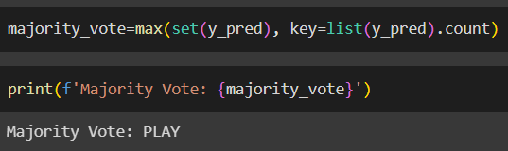

Since implementation requires interfacing with the underlying OS's management functions, administrative privileges would have to be provided to the Jupyter Notebook to run.

I will make use of the Python *ctypes* library to call the Windows API functions. According to the official Python documentation, ctypes provides C compatible data types and allows to call DLLs. Thus the imported library will allow runtime loading of DLLs which will enable me to access system-level functionality under due control and support of the Windows OS.

My laptop has two modes for refresh rate settings: 48 Hz and 60 Hz, so I will be catering the change in refresh rate to the same.

For tasks like *watch*, 60 Hz is more than optimum with a balanced/medium performance mode. Higher refresh rates do not make a noticeable difference in the viewing experience, therefore we keep it to 60Hz.

For immersive tasks such as *playing*, the highest refresh rate is required along with high performance mode enabled in the battery plans.

Tasks like *read, write* and *debug* can easily be performed at 48Hz and at quiet/low performance mode.

For *browsing*, to enable more frames per second, the refresh rate can be either 48Hz or 60Hz but balanced performance mode is preferred.

Battery plans do have a certain default brightness level associated to them but my code should be able to provide a temporary override and change the brightness setting to better suit the task being performed by the user.

END GOALS

TRAINING AND FINE TUNING OF THE MODEL

As described before, knowing what hyperparameters cause what effect and to what degree is imperative to understand how the model is treating and processing my given dataset. I will be putting in variations of my training data set in multiple iterations to understand what features affect the predictive power of my model and try to tune out any misaligned parameters.

PYTHON CODE TO ACCESS WINDOWS API

Figuring out the code that will support access and modification of the above mentioned system properties and their integration within the ML model code is essential for producing an application that delivers dynamic adaptation of system settings in accordance to the activity being performed on it.

BRIGHTNESS ADAPTATION

I haven’t yet gained clarity on what exact metric I will be defining the brightness level suited during a particular activity on. Intensity of backlight as such is adjusted on feedback from ambient light sensors. Since I am not relying on an external light sensor or integrated camera for information about brightness or user preferences, optimal brightness as a general idea during tasks is known to me. The complexity of the code and difficulty in understanding the backlight features is something I will be taking the help of my mentors on in the next few days.

Google drive link for all resources in a single folder of BYOP 24 Mid Eval:

<https://drive.google.com/drive/folders/1BxtmfMBfJ61iWOftNvABQMxPWcZEOA1b?usp=sharing>